

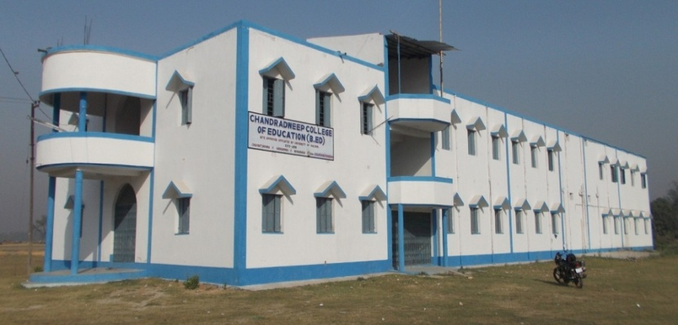
NOTEBOOK ON

COMMUNITY
BASED ACTIVITIES

NAME:-
ROLL:-000000NO.:- 000000
REGI. NO.:- 000000
B.Ed, SEMESTER – III, 2017
WBUTTEPA
UNIVERSITY OF KALYANI

NOTEBOOK ON

ENGAGEMENT WITH
FIELD/PRACTICUM – (COURSE VIIB)

ENGAGEMENT WITH
FIELD/PRACTICUM – (COURSE VIIB)

ENGAGEMENT WITH
FIELD/PRACTICUM – (COURSE VIIB)

ENGAGEMENT WITH
FIELD/PRACTICUM – (COURSE VIIB)

NAME:-
ROLL:-000000NO.:- 000000
REGI. NO.:- 00000
B.Ed, SEMESTER- III
UNIVERSITY OF KALYANI
WBUTTEPA

UNIVERSITY OF KALYANI
UNIVERSITY OF KALYANI
UNIVERSITY OF KALYANI

NOTEBOOK ON

School Internship (Learning Design)

NAME:-
ROLL:-000000NO.:- 000000
REGI. NO.:- 000000
B.Ed, SEMESTER – III, 2017
WBUTTEPA
UNIVERSITY OF KALYANI

NOTEBOOK ON

Final Teaching
Learning Design

ENGAGEMENT WITH
FIELD/PRACTICUM – (COURSE VIIB)

ENGAGEMENT WITH
FIELD/PRACTICUM – (COURSE VIIB)

ENGAGEMENT WITH
FIELD/PRACTICUM – (COURSE VIIB)

NAME:-
ROLL:-000000NO.:- 000000
REGI. NO.:- 00000
B.Ed, SEMESTER- III
UNIVERSITY OF KALYANI
WBUTTEPA

UNIVERSITY OF KALYANI
UNIVERSITY OF KALYANI
UNIVERSITY OF KALYANI

NOTEBOOK ON

Feedback Diary

ENGAGEMENT WITH
FIELD/PRACTICUM – (COURSE VIIB)

ENGAGEMENT WITH
FIELD/PRACTICUM – (COURSE VIIB)

ENGAGEMENT WITH
FIELD/PRACTICUM – (COURSE VIIB)

NAME:-
ROLL:-000000NO.:- 000000
REGI. NO.:- 00000
B.Ed, SEMESTER- III
UNIVERSITY OF KALYANI
WBUTTEPA

UNIVERSITY OF KALYANI
UNIVERSITY OF KALYANI
UNIVERSITY OF KALYANI

UNIVERSITY OF KALYANI
UNIVERSITY OF KALYANI
UNIVERSITY OF KALYANI
UNIVERSITY OF KALYANI
UNIVERSITY OF KALYANI
UNIVERSITY OF KALYANI

